# User Interface (UI)

In game, the user interface will include a "Pause" button, which will open the pause menu in the middle of the screen. The following options will be available in this window:

●New Game

○ Easy

○ Medium

○ Hard

● Top-10

● Exit Game

● Back

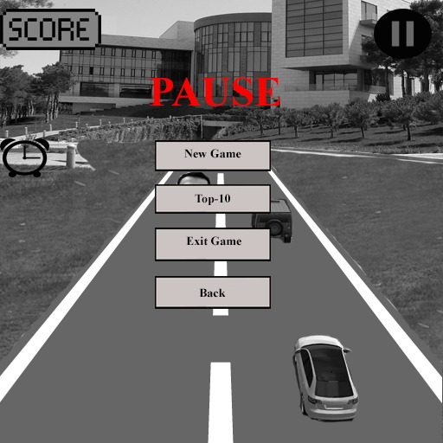

## Heads up Display (HUD)

On the left side of the display will be located score and time boxes.

**Score box** - indicates the number of points which player has earned at the present time.

**Time box** - will indicate the time that has passed since the beginning of the new game.

On the right side of the display will be located a "Pause" button.

**"Pause" Button** - when you press the pause button, the game will pause and the pause menu will open.

## Player View

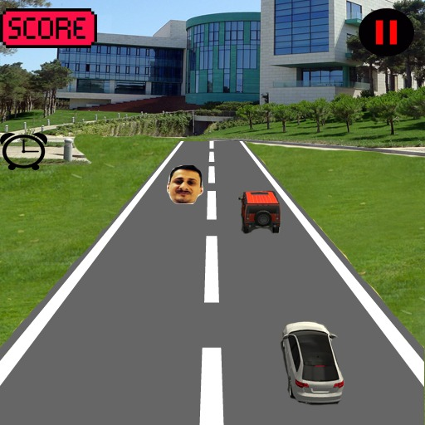

Due to the fact that our game is about racing and it is 3D, the camera will show everything from a third party. The camera will be moving and it will move behind your car.

# Game Architecture

• Main Screen

• New Game Screen

• Pause Screen

**Main Screen**

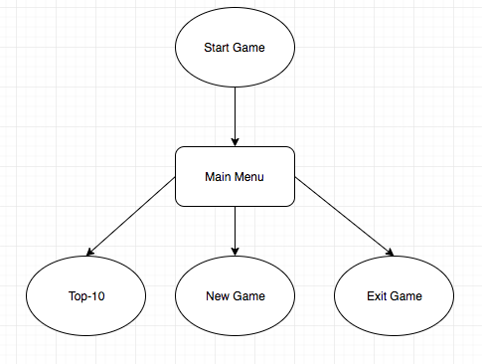

**New Game Screen**

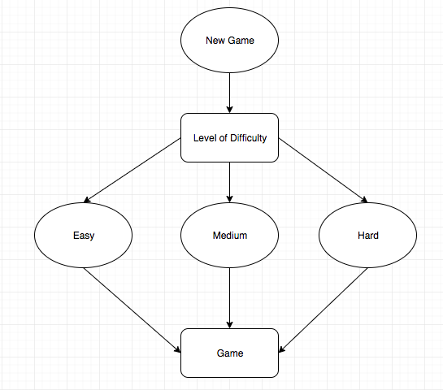

**Pause Screen**

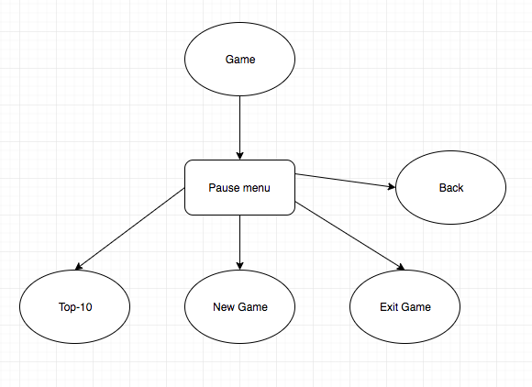

## Game Architecture Overview

Main menu:

●New Game

○ Easy (low speed)

○ Medium (middle speed)

○ Hard (fast speed)

● Top-10

● Exit Game

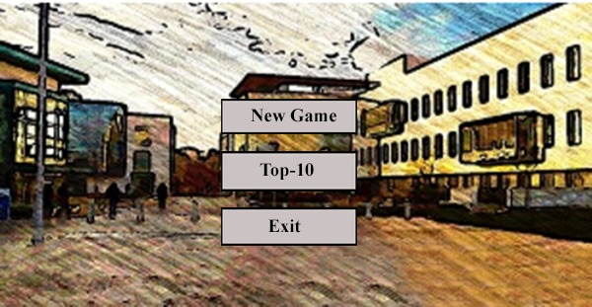

## Architecture Copy

The main menu is designed with the most necessary parameters for the player. It provides options that have been given above that the user may want to experience during the game. When choosing a New Game, the player will have to choose the complexity of the game, depending on his choice, the speed of the game will change accordingly. Top-10 will show 10 best game results. Moreover, it will be also possible to exit game if a player wants to leave it.

## How to Play Copy

The game starts, all indicators such as time and points at zero, the car starts to go, the speed of your car depends on the level of difficulty you choose. The machine will move automatically; you only need to have time to turn left or right. Players should press ← and → keys to move to the left and to the right. The main goal of the game is not to hit obstacles and collect the maximum number of points within the shortest time. On your way there will be obstacles in the form of cars. However, besides obstacles you will also meet bonuses on your way. Bonus 1, Gulmammad Gulmammadov: Using gravity which attacks other cars to the ground to limit their movement of the cars. Bonus 2, Emin Alasgarov: Encrypts the car, making it untouchable which frees him from obstacles on the road. Bonus 3, Samir Rustamov: Uses car speed booster to overtake the opponents' cars and adds +10 seconds to time. Bonus 4: Araz Yusubov: Turns the car into a bus no 77 and adds x2 Score. The game is endless, the game will continue until the player loses. If the player has lost, he can choose the new game again to beat your previous best record or exit game.